Business Process: Power Factor Waiver Agreement

Contact
Business Process Owner | Billing Operations – Billing Solutions
Subject Matter Expert(s) | Amanda De La Cruz, Katherine Martinez, Michele Gwin, Shannon Whitley
Key Contact | Maya Duarte
Key Role | Customer Services Representative II  Senior Customer Services Representative
Date Created | 4/29/2026

Business Process Overview
Power Factor measures the relationship between kilowatts (kW) and kilovars (kVAR) required by a customer’s metered load and is expressed as a percentage. A power factor of 100% means no kVAR support is needed. SMUD does not apply power factor adjustment charges when a customer’s power factor is 95% or greater, whether leading or lagging. For demand-rate accounts, a Power Factor Adjustment charge may apply when power factor falls below 95%.
Customers may request a Power Factor Waiver contract through their Strategic Account Advisor (SAA). This waiver provides a fixed monthly charge for the contract term instead of the variable Power Factor Adjustment charge. The waiver is based on the highest kVAR from a historical 12-month period and is not available for customers served at the subtransmission voltage level.
The process begins when the customer requests a waiver review through the SAA, who prepares the report and contract. If approved, the customer signs and returns the contract, the SAA completes execution, and Billing enters the charge into SAP. Either party may terminate the waiver with 30 days’ written notice, or immediately upon default. When terminated, the account becomes subject to applicable power factor adjustments.

Business Process Assumptions, Prerequisites, Dependencies
(Assumptions pertaining to the business process)
People | - Assumptions:  - Strategic Account Advisors (or equivalent account staff) are trained on the power factor waiver process.  - Billing staff are trained to verify waiver contracts and apply the correct charge in SAP.  - Prerequisites:  - Customer request the power factor waiver through the Strategic Account Advisor.  - Customer signed the waiver contract.  - Strategic Account Advisor signs and forwards the contract to Billing.  - Dependencies:  - Strategic Account Advisor, Customer, Billing, and Pricing when additional analysis is needed.
Process | - Assumptions:  - Power factor is a measure of the relationship between kW and kVAR for the customer’s metered load.  - SMUD exempts customers from adjustment charges when power factor is 95% or greater, whether leading or lagging.  - The default power factor adjustment charge is based on monthly energy and power factor.  - The waiver charge is based on the highest kVAR over a historical 12-month period.  - Prerequisites:  - At least 12 months of kVAR history is typically needed to produce the waiver contract.  - The waiver contract must be executed by both the customer and SMUD.  - The contract must be on file before Billing can establish the monthly waiver charge.  - Customers at the subtransmission service voltage level are not eligible.  - Dependencies:  - Pricing analysis tool to generate the report and contract.  - Billing to enter the contract waiver charge into SAP.  - Annual review process to update waiver amounts.  - Pricing staff if less than 12 months of data is available.
Technology | - Assumptions:  - Meter data for kWh, kW, and kVAR is available and accurate.  - SMUD can compute kVA from metered kW and kVAR as needed.  - SAP and supporting billing tools are available (IEE, UIQ).  - Prerequisites:  - Pricing analysis tools have sufficient billing history and kVAR data.  - Billing has access to the executed contract copy or link.  - Signatures and waiver amount can be verified before SAP entry.  - Dependencies:  - Smart meter data.  - Pricing analysis tool.  - SAP billing system.  - Document access for signed contract.  - Annual SAP program that updates waiver amounts see supporting documents for further details.  - ZCS_PWR_FACTOR_WAIVER_NEW publishes results to the ZCCS Report Tree

Process Flowchart
Power Factor Waiver Agreement Process Mapping As Is.vsdx

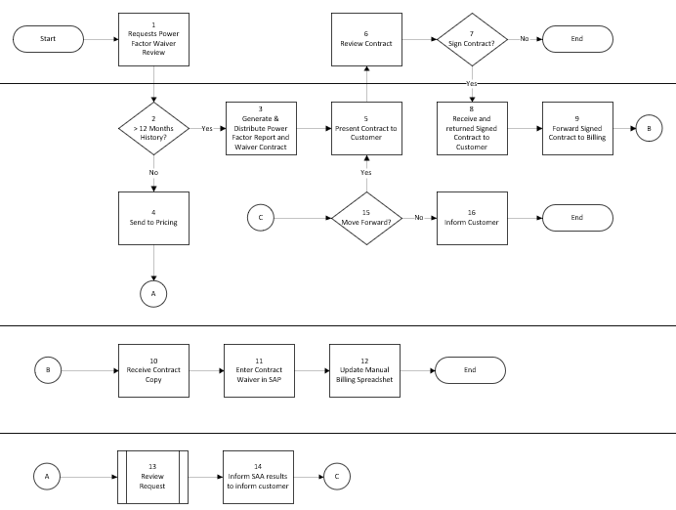

Task Description
Id | Task Description | Procedure
1 | Requests Power Factor Waiver Review | Customer/service request initiates the power factor waiver review.
2 | > 12 Months History? | Check whether the customer has more than 12 months of history. If yes, continue to Step 3. If no, go to Step 4.
3 | Generate & Distribute Power Factor Report and Waiver Contract | Prepare and distribute the Power Factor Report and Waiver Contract.
4 | Send to Pricing | Send the request to Pricing for review.
5 | Present Contract to Customer | Present the contract to the customer.
6 | Review Contract | Review the contract before requesting signature.
7 | Sign Contract? | Determine whether the contract is signed. If yes, continue to Step 8. If no, end the process.
8 | Receive and returned Signed Contract to Customer | Receive the signed contract back from the customer.
9 | Forward Signed Contract to Billing | Forward the signed contract to Billing.
10 | Receive Contract Copy | Receive the contract copy from Billing/return flow.
11 | Enter Contract Waiver in SAP | Enter the contract waiver into SAP.
12 | Update Manual Billing Spreadsheet | Update the manual billing spreadsheet.
13 | Review Request | Pricing Reviews Request
14 | Inform SAA results to inform customer | Pricing informs SAA of results from analysis
15 | Move Forward? | Decide whether to continue. If yes, return to Step 5. If not, proceed to Step 16.
16 | Inform Customer | Inform the customer that the process will not move forward.

Business Rules
Id | Event Name | Business Rules
1 | Requests Power Factor Waiver Review | Power factor adjustment charges may apply to demand-rate accounts when power factor falls below 95% leading or lagging.
2 | > 12 Months History? | Customers with power factor at or above 95% are exempt from power factor adjustment charges.
3 | Generate & Distribute Power Factor Report and Waiver Contract | The default power factor adjustment charge is based on monthly energy and power factor.
3 | Generate & Distribute Power Factor Report and Waiver Contract | The power factor waiver is a contract-based alternative charge based on the highest kVAR over a historical 12-month period.
3 | Generate & Distribute Power Factor Report and Waiver Contract | The pricing analysis tool requires 12 months of customer data, including kVAR reads, to create a waiver contract.
3 | Generate & Distribute Power Factor Report and Waiver Contract | Power factor waiver contracts cannot be established based on a previous customer’s usage.
3 | Generate & Distribute Power Factor Report and Waiver Contract | Waiver amounts are reviewed and updated annually based on the most recent 12 months of kVAR history.
3 | Generate & Distribute Power Factor Report and Waiver Contract | Only customers with an active waiver contract for at least 12 months are subject to annual updated waiver amounts.
5 | Present Contract to Customer | A power factor waiver contract is voluntary and must be signed by both the customer and SMUD.
7 | Sign Contract? | Either party may terminate the waiver contract with 30 days’ written notice, or immediately upon notice of default.
7 | Sign Contract? | SMUD may adjust the amount of kVAR subject to correction with 30 days’ written notice.
7 | Sign Contract? | Once terminated, the customer becomes subject to applicable power factor adjustment charges effective on the termination date.
11 | Enter Contract Waiver in SAP | Billing must enter the waiver charge into SAP after receiving the executed contract copy.
11 | Enter Contract Waiver in SAP | If the kVAR rate type is marked non-relevant, staff must notify their lead and supervisor.
13 | Review Request | If 12 months of data is unavailable, Pricing may create a contract only if the available history includes a full summer period (June 1 through September 30).
13 | Review Request | If a full summer period is not available, a waiver contract cannot be created until all four summer months have been billed.

Event | Legal Requirements, Rules, and Regulations  Legal documents/ procedures/ requirements to be fulfilled before/at the specified event.
Id | Event | Legal Requirements, Rules and/or Regulations
 |  | N/A

Pain Points and Improvement Opportunities
Adding Power Factor Waiver Agreement
- In SAP, Power Factor Charges can be applied to CITS-0 due to operator error. Since CITS-0 is exempt, this should be prevented at the rate structure level rather than relying on external checks.
- The pricing analysis tool that generates reports and contracts is currently done in Excel by extracting data from SAP. These calculations could be completed within SAP, removing the hand-off and enabling a self-service path for the Strategic Account Advisor and our customers directly.
Removing Power Factor Waiver Agreement
- N/A
Annual Audit
- ZCS_PWR_FACTOR_WAIVER_NEW publishes results to the ZCCS report tree which is being replaced.

Departments impacted by process change (Required)

Department | Type of Change(s) | Action Required
Billing
Commercial Delivery
Pricing

Supporting Documentation
(Any subsequent documentation in support of this business process (i.e. business requirements, technical specs, etc.) shall be summarized in the following table.)
Document Type | Link
Business Procedures | Power Factor Charges & Waivers.pdf
Business Procedures | Rate Policy and Procedure Manual - 9-04 - Power Factor Charge.pdf
Technical Specifications | \\server01\dept-btcm\CCS\Specification_Documents\RTR-Reports\ETR-CS194 Automate Update of Power Factor Waiver.doc

Business Blueprint Amendments

Any subsequent changes to this business process blueprint after the official document approval shall be summarized in the following table. This document must be reprinted and signed by the authorized representatives.
Version | Author | Description of Change | Approval (Name/Sign) | Date
1.0 | Joshua Dunn | Initial Draft | Maya Duarte | 4/30/2026

